2A2B HUMAN BIOLOGY DIGESTIVE SYSTEM TEST

Name:_____________________________ Teacher: __________________ /61

Part one – multiple choice

1. Digestion begins in the mouth. Which of the following statements is INCORRECT?

a) The tongue aids in the digestion of food.

b) The saliva changes some of the starches in the food to sugar.

c) The tongue keeps the food in place in the mouth while the food is being chewed.

d) Saliva can react more easily with the food when chewed.

2. Our pharynx divides into two separate tubes: the trachea and the oesophagus. What prevents food from entering the trachea?

a) The uvula.

b) The tongue.

c) The trachea.

d) The epiglottis.

3. Where does the partly-digested food (in liquid form) go after it leaves the stomach?

a) The liver.

b) The appendix.

c) The small intestine.

d) The large intestine.

4. Digestion takes place in a long tube-like canal called the alimentary canal, or the digestive tract. Food travels through these organs in the following order:

a) Mouth, oesophagus, stomach, small intestine, large intestine and rectum.

b) Mouth, oesophagus, stomach, large intestine, small intestine and rectum.

c) Mouth, stomach, oesophagus, small intestine, large intestine and rectum.

d) Mouth, stomach, oesophagus, small intestine, large intestine and rectum.

5. Another term for swallowing of food is:

a) Digestion.

b) Ingestion.

c) Deglutition.

d) Peristalsis.

Part two – short answer

1. Write the dental formula for humans.

___________________________________________________________________________________________

(1 mark)

2a. What special substance does the liver produce? ____________________ (1 mark)

2b. What does this substance do?

____________________________________________________________________________________

(1 mark)

2c. Where is this substance stored? ________________________ (1 mark)

3. Complete the table below.

|  |  |  |
| --- | --- | --- |
| Structure | Where they are found | Function |
| Circular and longitudinal muscle layers |  |  |
| Villi |  |  |
| Goblet cells |  |  |
| Mucus |  |  |

(8 marks)

4. Label the diagram below.

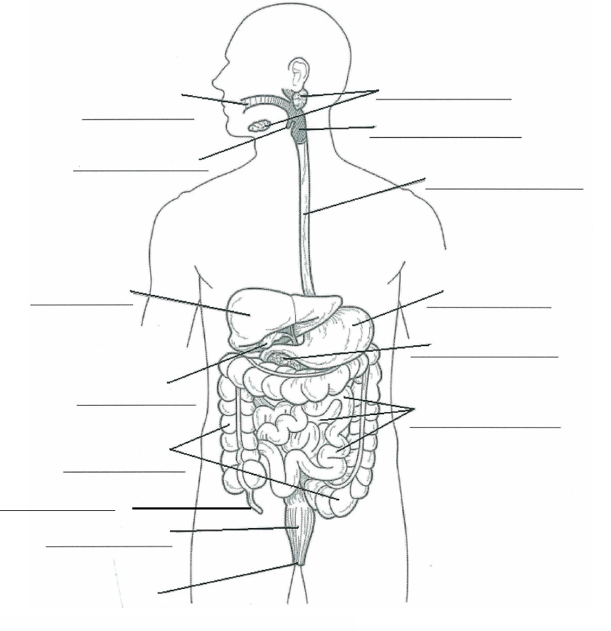

(7 marks)

5. Explain what peristalsis is.

____________________________________________________________________________________

____________________________________________________________________________________

(2 marks)

6. Fill in the table below.

|  |  |  |  |  |
| --- | --- | --- | --- | --- |
| Name of enzyme | Where it is made | Where it is found (used) | What it acts on (substrate) | Product |
| Salivary amylase |  |  |  |  |
| Pancreatic lipase |  |  |  |  |
| Pancreatic protease (trypsin) |  |  |  |  |
| Pancreatic amylase |  |  |  |  |
| Gastric protease (pepsin) |  |  |  |  |

(20 marks)

Part three – extended answer

1. Vitamin D, vitamin C and Vitamin B1 are all important vitamins which your body needs to keep healthy. For each of these vitamins, state a deficiency disease caused by a lack of the vitamin, two symptoms of the deficiency and two food sources of the vitamin. (15 marks)

___________________________________________________________________________________________

___________________________________________________________________________________________

___________________________________________________________________________________________

___________________________________________________________________________________________

___________________________________________________________________________________________

___________________________________________________________________________________________

___________________________________________________________________________________________

___________________________________________________________________________________________

___________________________________________________________________________________________

___________________________________________________________________________________________

___________________________________________________________________________________________

___________________________________________________________________________________________

___________________________________________________________________________________________

___________________________________________________________________________________________

___________________________________________________________________________________________

___________________________________________________________________________________________

___________________________________________________________________________________________

___________________________________________________________________________________________

___________________________________________________________________________________________

___________________________________________________________________________________________

___________________________________________________________________________________________

___________________________________________________________________________________________

___________________________________________________________________________________________

___________________________________________________________________________________________

___________________________________________________________________________________________

___________________________________________________________________________________________

___________________________________________________________________________________________